Chapter III
Disaster Medical OperationsPart 1

In this chapter you will learn about

 Life-threatening conditions: How to recognize and treat airway obstruction, bleeding, and shock.
 Triage: Principles of triage and how to conduct triage evaluations.

Introduction

Most disasters are relatively unexpected, endanger lives and health, and overwhelm existing emergency resources. These elements lead to some basic assumptions about disaster medical operations:

 The number of victims will exceed local capacity for treatment.

 Survivors will assist others. They will do whatever they know how to do, although it cannot be assumed that most people know lifesaving first aid or post-disaster survival techniques.

The American College of Surgeons has described three phases of death due to trauma:

 Phase 1. Death within minutes due to overwhelming and irreversible damage to vital organs.

 Phase 2. Death within several hours due to excessive bleeding.

 Phase 3. Death in several days or weeks due to infection or multiple-system failure (i.e., not from the injury per se).

Experts agree that over 40 percent of disaster victims in the second and third phases of death could be saved by providing simple medical care. CERT disaster medical operations personnel are trained to provide treatment for life-threatening conditionsairway obstruction, bleeding, and shockand treatment for other less urgent conditions. They are also trained to provide the greatest good for the greatest number of victims through principles of triage. Given the overwhelming nature of disasters, the CERT members’ training in medical operations can play a critical role in disaster response.

Introduction
(Continued)

This chapter will introduce disaster medical operations and train you to:

 Recognize and treat life-threatening conditions (i.e., open the airway, control bleeding, treat for shock).

 Conduct triage evaluations.

Remember that the goal of disaster medical operations is to do the greatest good for the greatest number.
Your instructor may present additional information not covered in this Participant Handbook. Be sure to take notes during the classroom presentation of this material.

RESCUER SAFETY: Be sure to wear a helmet, goggles, mask, gloves, and boots for all medical operations.

Recognizing And Treating Life-Threatening Conditions

Introduction

In emergency medicine, airway obstruction, bleeding, and shock are “killers”life-threatening conditions that can kill a patient if not treated immediately. The first priority of medical operations workers is to attend to these potential killers by:

 Restoring breathing.

 Controlling severe bleeding.

 Ensuring adequate circulation (treating for shock).

When working in a disaster with multiple casualties, the first goal is Simple Triage And Rapid Treatment (START).

This section will train you how to recognize the “killers” by recognizing their symptoms and their effects on body systems. It will also provide you with practice in providing immediate treatment to minimize disaster casualties.

Opening The Airway

An airway obstruction is anything that hinders or prevents the exchange of oxygen and carbon dioxide through the body’s respiratory system. Through the respiratory system, we obtain oxygen by inhaling and rid ourselves of carbon dioxide by exhaling. Once in the lungs, oxygen is transferred to red blood cells and transported through the bloodstream to nourish our cells. The major components of the respiratory system are shown in Figure III-1.
Opening The Airway (Continued)

Figure III-1. Components Of The Respiratory System

An unconscious or semiconscious victim may have an obstructed airway. If the airway is obstructed, the victim cannot get oxygen, and the impact is felt very quickly in the heart and brain. A victim with suspected airway obstruction must be checked immediately for breathing, and if necessary, the airway must be opened.

Time is critical when dealing with airway obstructions. Heart function may be affected within the first few minutesand brain damage is possible after 4 minutes without oxygen.
Opening The Airway (Continued)

The most common airway obstruction is the tongue. In an unconscious victim, especially one positioned on his or her back, the tongue relaxes and may block the airway. This condition is shown in the figure below.

Figure III-2. Airway Obstructed By The Tongue
Opening The Airway (Continued)

When the victim is not breathing, use the Head-Tilt/Chin-Lift method of opening the airway. The Head-Tilt/Chin-Lift method involves following the six steps shown in the table below.

Step | Action
1 | At an arm’s distance, shake the victim by touching the shoulder and shout, “Can you hear me?”
2 | If the victim does not or cannot respond, place one hand on the forehead.
3 | Place two fingers of the other hand under the chin and tilt the jaw upward while tilting the head back slightly.
4 | Look for chest rise.
5 | Listen for air exchange.
6 | Feel for abdominal movement.

Table III-1. Head-Tilt/Chin-Lift Method For Opening An Airway

If the victim does not start breathing using the Head-Tilt/Chin-Lift method, try the procedure one more time. If the victim does not respond the second time, move on to the next victim. Remember, the CERT team’s mission is to do the greatest good for the greatest number of victims possible. Although it may be difficult to leave the victim, it is necessary to do so under disaster circumstances.

If the victim begins breathing, the airway must still be maintained. Try to get a volunteer to hold the head back to maintain the open airway, or place something (such as a shoe or soft object) under each of the victim’s shoulders to slightly elevate the shoulders, which will keep the airway open.

Controlling Bleeding

Uncontrolled bleeding initially causes weakness. If bleeding is not controlled within a short period, the victim will go into shock (described in the next section), and finally die. The average adult has about 5 liters of blood. Because the loss of just 1 liter poses a risk of death, it is critical that excessive bleeding be controlled in the shortest amount of time possible.

There are three main types of bleeding. The type can usually be identified by how fast the blood flows.

 Arterial Bleeding. Arteries transport blood under high pressure. Therefore, bleeding from an artery is spurting bleeding.

 Venous Bleeding. Veins transport blood under low pressure. Bleeding from a vein is flowing bleeding.

 Capillary Bleeding. Capillaries also carry blood under low pressure. Bleeding from capillaries is oozing bleeding.

Use one or more of the procedures on page III-10 to control bleeding. If you cannot control the bleeding using one method, try another, or a combination of methods.
Controlling Bleeding (Continued)

Method | Procedures
Direct Local Pressure |  Place direct pressure over the wound by putting a clean pad over the wound and pressing firmly.   Maintain compression by wrapping the wound firmly with a pressure bandage.
Elevation |  Elevate the wound above the level of the heart.
Pressure Points |  Put pressure on the nearest pressure point to slow the flow of blood to the wound. A pressure point is a pulse point for a major artery. Use the:  - Brachial point for bleeding in the arm.  - Femoral point for bleeding in the leg.  (See the figures on the following page for illustrations of these pressure points.)  There are other pressure points that your instructor may demonstrate.

Table III-2. Procedures For Controlling Bleeding

Ninety-five percent of bleeding can be controlled by direct pressure combined with elevation.

Controlling Bleeding (Continued)

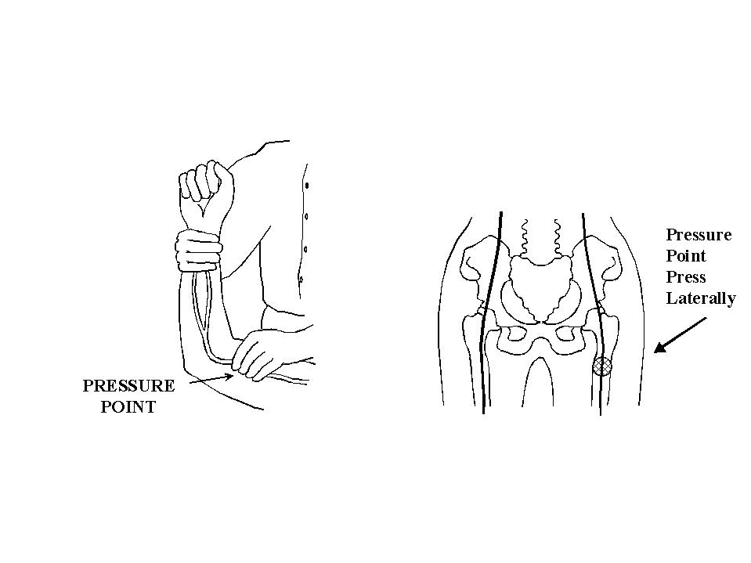
Figure III-3.  Brachial Pressure Point | Figure III-4.  Femoral Pressure Point
Controlling Bleeding (Continued)

An illustration of the three main methods to control bleeding is shown in the figure below.

Figure III-5. Methods For Controlling Bleeding
Controlling Bleeding (Continued)

If none of the other methods for controlling bleeding is successful, a tourniquet may be necessary. A tourniquet is rarely required and should be used only as a last resorta “life or limb” situation. Tourniquets are considered appropriate treatment for crushing-type injuries and for partial amputations. Using a tourniquet can pose serious risks to the affected limb, so it should not be used unless not using it will endanger the person’s life from excessive blood loss. The most serious dangers in tourniquet use stem from:

 Incorrect materials or application, which increases the damage and bleeding. If narrow materials are used or the tourniquet is too tight, nerves, blood vessels, and muscles may be damaged.

 Damage to the limb from a tourniquet. Survival of a limb is almost never possible after a correctly applied tourniquet is left in place too long. Only a physician should remove a tourniquet. If you apply a tourniquet, leave it in plain sight (don’t bandage over it), and attach an adhesive label to the victim’s forehead stating the time the tourniquet was applied.

NOTE: Detailed information on dressing and bandaging is provided in Chapter IV.

Your instructor will demonstrate application of a tourniquet. Procedures for using a tourniquet are illustrated in Figure III-6 on the next page.
Controlling Bleeding (Continued)

Figure III-6. Tourniquet
Recognizing And Treating For Shock

Shock is a disorder resulting from ineffective circulation of blood. Remaining in shock will lead to the death of cells, tissues, and entire organs.

Initially, the body will compensate for blood loss, so signs of shock may not appear immediately. It is important, therefore, to continually evaluate and monitor the victim’s condition. Observable symptoms of shock to look for are:

 Rapid, shallow breathing (rate greater than 30 per minute).

 Cold, pale skin (capillary refill greater than 2 seconds).

 Failure to respond to simple commands, such as “Squeeze my hand.”

To treat a person for shock, follow the steps in the table below.

Step | Procedure
1 |  Lay the victim on his or her back.   Elevate the feet 6-10 inches.   Maintain an open airway.
2 |  Control obvious bleeding.
3 |  Maintain body temperature (e.g., cover the ground and the victim with a blanket).
4 |  Avoid rough or excessive handling.

Table III-3. Procedures For Controlling Shock
Recognizing And Treating For Shock (Continued)

An illustration of correct shock position is shown in the figure below.

Figure III-7. Shock Position

Do not give a victim who is suffering from shock anything to eat or drink. People in shock may be nauseous and thirsty.

In a disaster scenario, you may have many victims requiring attentionand few resources to use. The remainder of this chapter will address the triage system for analyzing victim condition and prioritizing treatment.
Triage

What Is Triage?

Triage is a French verb, meaning “to sort.” Victims are evaluated, sorted by immediacy of treatment needed, and set up for immediate or delayed treatment. Military experience has shown that triage is an effective strategy in situations where rescuers are overwhelmed, there are limited resources, and time is a critical factor.

Triage occurs as quickly as possible after a victim is located or rescued. Triage personnel evaluate victims’ conditions and sort them into three categories:

 Immediate (I). The victim has life-threatening (airway, bleeding, or shock) injuries that demand immediate attention to save his or her life; rapid treatment is imperative.

 Delayed (D). Injuries do not jeopardize the victim’s life if definitive treatment is delayed. Victim may require professional care, but immediate treatment is not imperative.

 Dead (DEAD). No respiration after two attempts to open the airway. (CPR is not performed in the disaster environment because resuscitation of a person in full cardiorespiratory arrest takes a tremendous amount of time and human resources.)

The goal of triage is to do the greatest good for the greatest number of victims.

What Is Triage? (Continued)

From triage, victims are taken to the designated medical treatment area (immediate care, delayed care, or morgue) and from there are transported out of the disaster area. The flow of patients is illustrated below.

Figure III-8. Triage Patient Flow
Triage In A Disaster Environment

Triage, like other disaster response efforts, begins with size-up. The general procedure for triage in a disaster environment is as follows:

 Stop, Look, Listen, and Think. Before you start, stop and size up the situation by looking around you and listening. Above all, THINK about how you will approach the task at hand. Continue to size up the situation as you work.

 Conduct Voice Triage. Begin with voice triage, calling out something like, “Emergency Response Team. If you can walk, come to the sound of my voice.” Instruct those survivors who are ambulatory to remain at a designated location, and continue with the triage operation.

 Follow A Systematic Route. Start with victims closest to you and work outward in a systematic fashion.

 Conduct Triage Evaluation. Evaluate victims and tag them I (immediate), D (delayed), or DEAD. Remember to evaluate the walking wounded. Everyone must get a tag.

 Treat “I” Victims Immediately. Initiate airway management, bleeding control, and/or treatment for shock for Category I (immediate) victims.

 Document Results. Document triage results for:

- Effective deployment of resources.
- Information on locations of victims.
- A quick record of the number of casualties by degree of severity.

This will be very useful information for responders and transportation units.

Always wear protective gear when performing triage, so that you do not endanger your own health.

Performing A Triage Evaluation

Use the procedures below when performing triage.

Step | Procedures
1 | Check airway/breathing. At an arm’s distance, shake the victim and shout. If the victim does not respond:   Position the airway.   Look, listen, and feel.   Check breathing rate. Abnormally rapid respiration (above 30 per minute) indicates shock. Treat for shock and tag “I.”   If below 30 per minute, them move to Step 2.   If the victim is not breathing after 2 attempts to open airway, then tag “DEAD.”
2 | Check circulation/bleeding:   Take immediate action to control severe bleeding.   Check circulation using the blanch test (for capillary refill).  - Press on an area of skin until normal skin color is gone. A good place to do this is on the palm of the hand. The forehead and nailbeds are sometimes used.  - Time how long it takes for normal color to return.   Treat for shock if normal color takes longer than 2 seconds to return, and tag “I.”
3 | Check mental status. Give a simple command, such as “Squeeze my hand.” Inability to respond indicates that immediate treatment for shock is necessary. Treat for shock and tag “I.”

Table III-4. Triage Procedure

If the victim passes all tests, then tag “D.” If the victim fails one test, tag “I.” Remember that everyone gets a tag.
Performing A Triage Evaluation (Continued)

The flowchart in Figure III-9 below illustrates the three triage steps and the decisions that you will be required to make during a triage evaluation.

Figure III-9. Triage Decision Flowchart

Note: The blanch test (used in Step 2) is not valid in children. Check mental status as the main indicator.
Triage Planning

There are several common problems in triage operations that can be avoided through careful planning and preparation. These include:

 Inadequate medical size-up.

 No team plan/organization/goal.

 Indecisive leadership.

 Too much focus on one injury. (In a disaster, time is critical. You cannot spend very much time with any single victim.)

 Treatment (rather than triage) performed.

Remember, triage is a process that needs to be practiced. Practicing triage in disaster simulations as often as you can will help you avoid these pitfalls.
Summary

Introduction

CERT members’ abilities to restore breathing, control severe bleeding, and treat for shock are critical to saving lives in the aftermath of a disaster.

Airway Obstructions

Time is critical when treating a victim who has an airway obstruction. The tongue is the most frequent obstruction. Breathing may be restored using the Head-Tilt/Chin-Lift method. Once a victim’s breathing has been restored, take steps to keep the airway open.

Excessive Bleeding

There are three types of bleeding that can be identified by the flow of blood:

 Arterial bleeding results in spurting blood.

 Venous bleeding results in excessive blood flow.

 Capillary bleeding causes oozing.

You can use one or more of the following methods to control bleeding:

 Placing pressure directly over the wound.

 Elevating the wound above the level of the heart.

 Putting pressure on the nearest pressure point to slow the flow of blood.
Excessive Bleeding (Continued)

In extreme cases, a tourniquet can be used. A tourniquet should be a last resort. It is only used in a life-or-limb situation where other methods have not controlled the bleeding.

Shock

Shock has symptoms that are readily observable. Shock requires immediate treatment, or death can result. To treat for shock:

 Lay the victim on his or her back. Elevate the feet 6-10 inches. Maintain an open airway.

 Control obvious bleeding.

 Maintain the body temperature.

 Avoid rough or excessive handling.

Never give a victim who is suffering from shock anything to eat or drink.

Triage

Triage is a system of rapidly evaluating victims and prioritizing treatment according to three categories:

 Immediate

 Delayed

 Dead

Triage (Continued)

The procedure for performing triage involves:

 Checking the airway and breathing rate.

 Checking circulation and controlling severe bleeding.

 Checking mental status.

Triage operations require careful planning and practice. Practicing triage in exercise situations can help avoid problems during an actual emergency.

Assignment

Before the next session:

 Read and familiarize yourself with Chapter IV: Disaster Medical OperationsPart 2.

Bring the following materials to the next session:

 Blanket

 1 box of roller gauze

 1 roll of adhesive tape (- or 1-inch)

 2 pieces of cardboard (approximately 4 inches  12 inches)

Additional Reading

The references below are available if you would like to know more about the information in this chapter.

California Specialized Training Institute. Disaster Medical Operations. Sacramento, CA: Office Of The State Fire Marshal, 1987.

Grant, Murry Jr., Bergeron, Brady. Brady Emergency Care, Fifth Edition. Prentice Hall, Englewood Cliffs, NJ: 1990.

Heckman, James D. (Ed.). Emergency Care And Transportation Of The Sick And Injured, Fifth Edition. American Association of Orthopaedic Surgeons, Park Ridge, IL: 1988.

Reader’s Digest Action Guide: What To Do In An Emergency. Pleasantville, NY: 1988.

U.S. Department Of Mine Safety. First Aid. U.S. Government Printing Office, Washington, DC: 1986.

U.S. Department Of The Navy. Self-Care/Buddy-Care. U.S. Government Printing Office, Washington DC: 1988.

The American Red Cross also provides resources on this subject. Contact your local chapter for information.

